MODULE 7 & 8 ASSESSMENT

- Try Test-Connection and nslookup commands for below websites
www.google.com
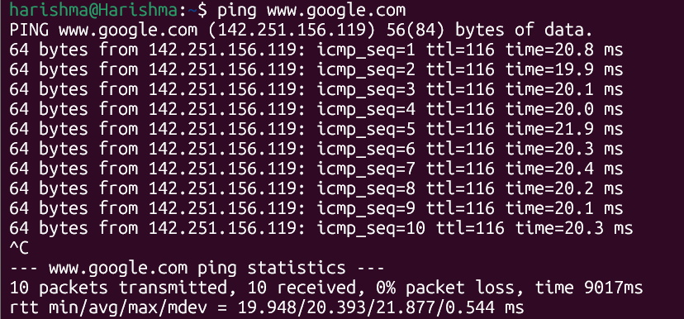
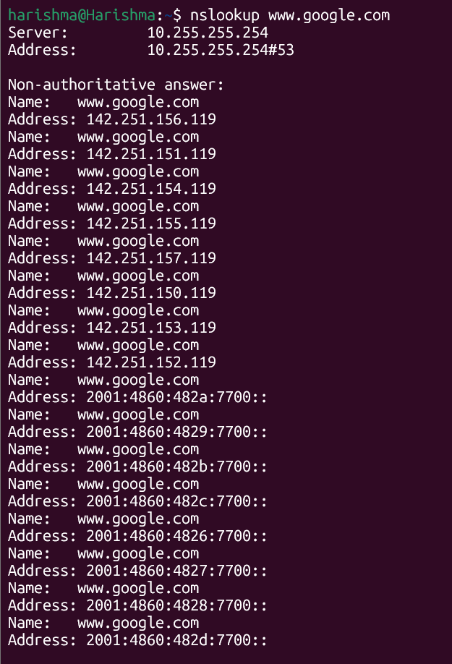
www.facebook.com
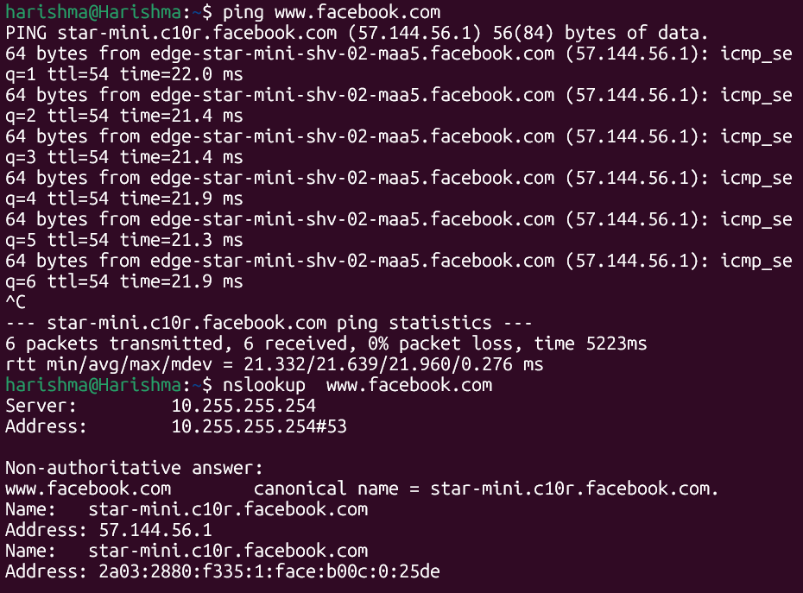
www.amazon.com

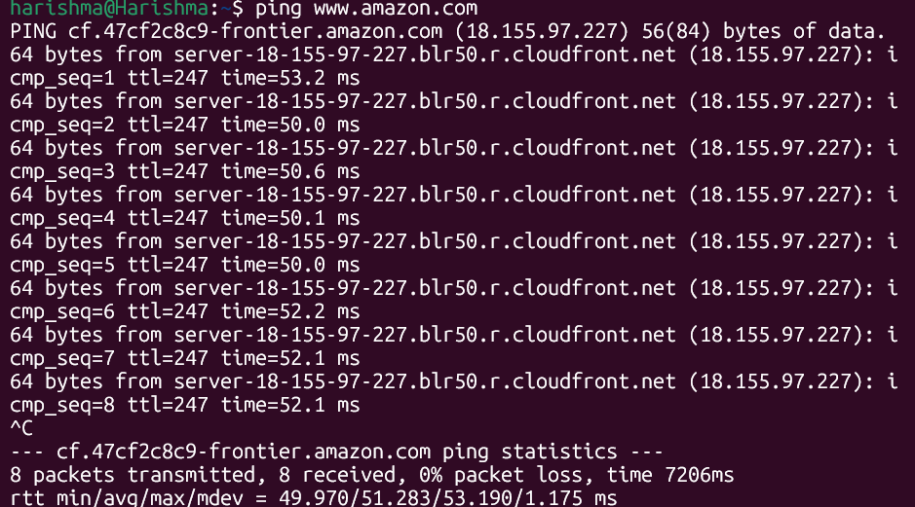
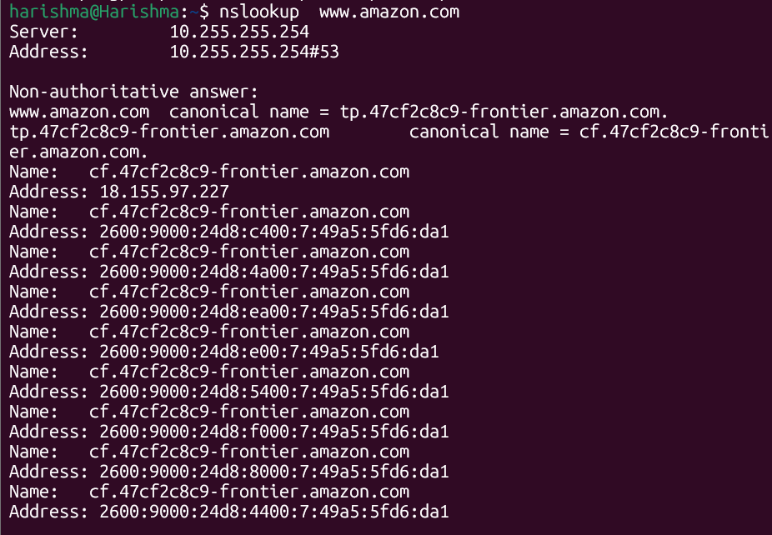
www.github.com
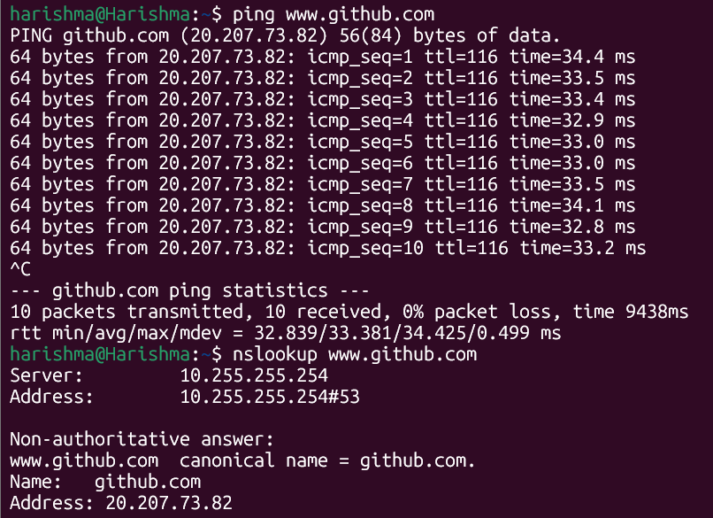

www.cisco.com
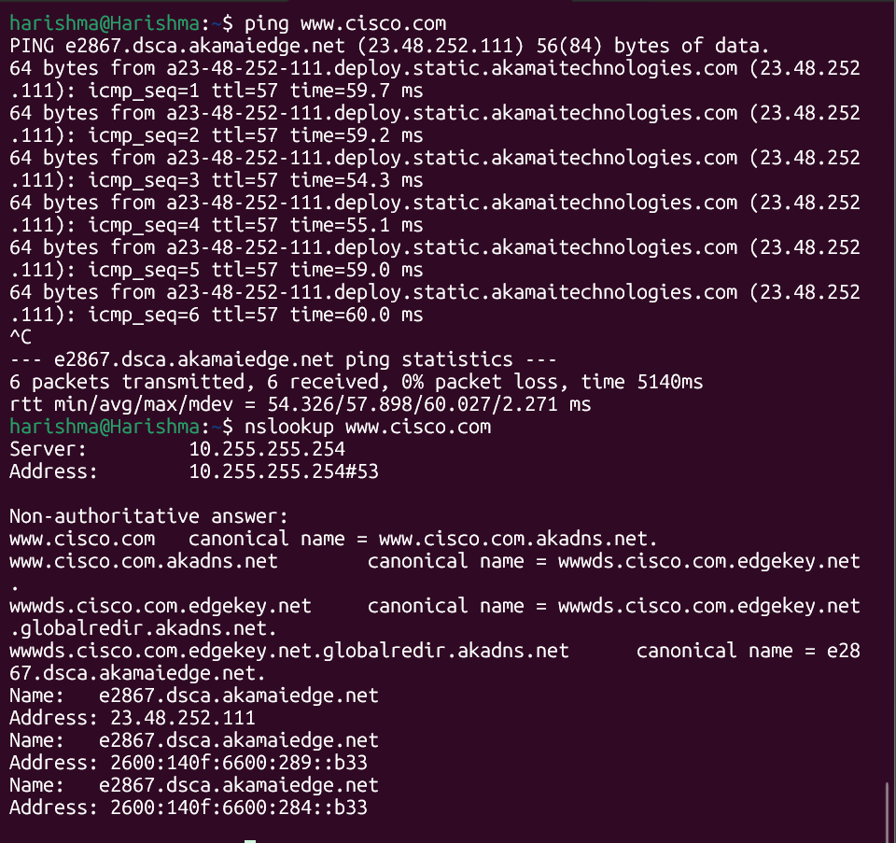

The connectivity to major websites such as Google, Amazon, Facebook, Cisco, and Github was successfully verified using the ping and nslookup commands, confirming that the system has stable internet access with no packet loss observed during transmission. The round-trip time (RTT) values varied slightly between websites, indicating differences in server proximity and network routing, with lower RTT reflecting better performance. DNS resolution using nslookup successfully translated domain names into IP addresses, and in several cases, multiple IP addresses were returned, demonstrating the use of load balancing and Content Delivery Networks (CDNs) to improve reliability and performance. Additionally, the TTL (Time To Live) values observed in the ping responses indicated the number of network hops and provided insight into server configurations. Overall, the results confirm proper network connectivity, efficient DNS functioning, and the use of modern web infrastructure techniques such as distributed servers and traffic optimization.
- Use Wireshark to capture and analyze DNS, TCP, UDP traffic and packet header, packet flow, options and flags
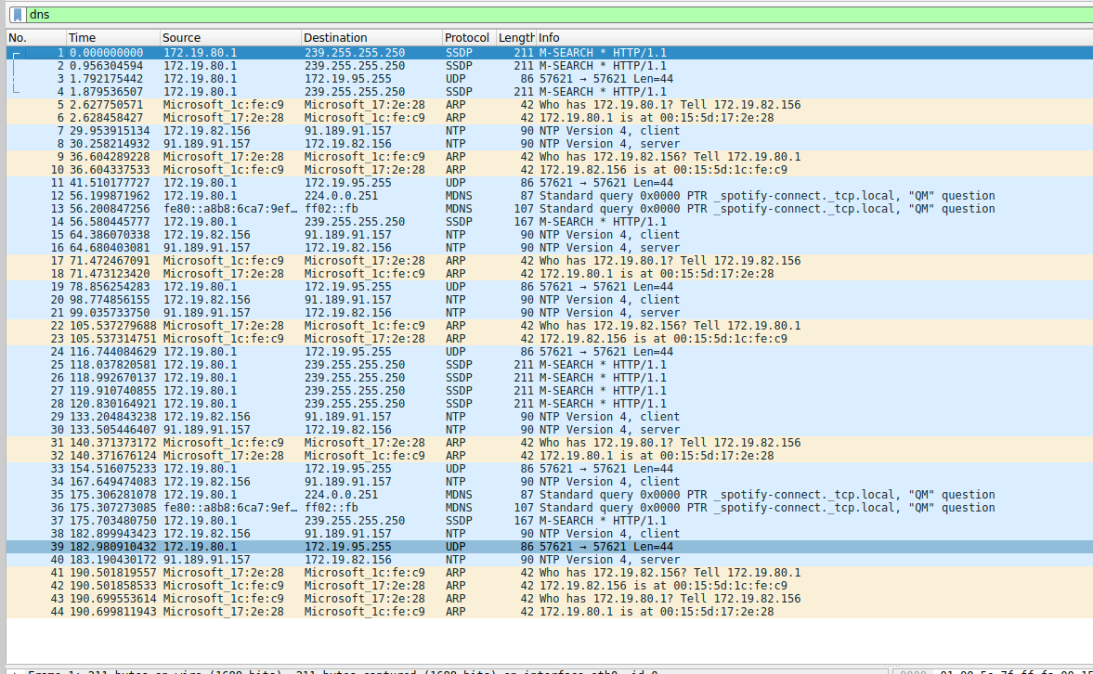

1. Types of Packets Observed
From your screenshot, the following protocols are visible:
- DNS → (you filtered it, but actual DNS may be minimal here)
- UDP
- ARP
- NTP
- SSDP
- MDNS
This indicates real background network activity, not just browser traffic.

2. Understanding Each Protocol in Capture

ARP (Address Resolution Protocol)
Example:
Who has 172.19.80.17? Tell 172.19.82.156
Meaning:
- Your system is asking:
  - “Who owns this IP?”
- Used to find MAC address from IP
Conclusion:
- ARP is used before communication begins

UDP (User Datagram Protocol)
Example:
UDP 57621 → 57621 Len=44
Meaning:
- Connectionless communication
- No guarantee of delivery
Used for:
- DNS
- Streaming
- Background apps

NTP (Network Time Protocol)
Example:
NTP Version 4, client / server
Meaning:
- Your system is syncing time with a server
Insight:
- Happens automatically in background

SSDP (Simple Service Discovery Protocol)
Example:
M-SEARCH * HTTP/1.1
Meaning:
- Device discovery in network (like smart devices)
Insight:
- Used in IoT / local network discovery

mDNS (Multicast DNS)
Example:
_spotify-connect._tcp.local
Meaning:
- Local device name resolution (without DNS server)
Insight:
- Used by apps like Spotify, printers, etc.

3. Packet Flow Observed
Your capture shows this flow:
- ARP request → Find device MAC
- UDP packets → Background communication
- NTP → Time synchronization
- SSDP/mDNS → Device discovery
This shows:
- Network is continuously active even without browser

4. Header Information Observed
Each packet contains:

Ethernet Layer
- Source MAC: Microsoft device
- Destination MAC

IP Layer
- Source IP: 172.19.x.x
- Destination IP

Transport Layer
- Protocol: UDP
- Port numbers
These layers follow the OSI model
- Explore traceroute/tracert for different websites eg: google.com and analyse the parameters in the output and explore different options for traceroute command
To analyze the path taken by packets from source to destination using the traceroute command and study parameters like hops, delay, and routing behaviour.
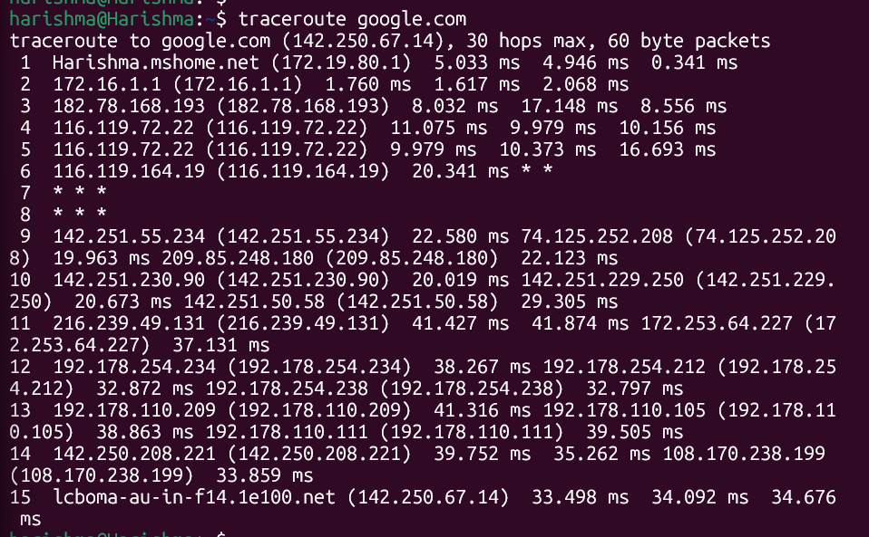
The traceroute output to Google shows the complete path taken by packets from the local system to the destination server, consisting of 15 hops. The first hop represents the local gateway (172.16.1.1) with very low latency, followed by several intermediate routers belonging to the Internet Service Provider, where the delay gradually increases. Some hops displayed asterisks (*), indicating that certain routers did not respond due to firewall restrictions or ICMP blocking, which is common in real-world networks. As the trace progresses, multiple IP addresses appear at the same hop, demonstrating load balancing and multiple routing paths within large networks. The later hops belong to Google’s backbone infrastructure, and the final destination resolves to a Google server (1e100.net) with an average round trip time of around 33–34 ms, indicating efficient connectivity. Overall, the output highlights key parameters such as hop count, round trip time, packet loss, and routing behavior, providing insight into how data travels across different network segments to reach the destination.

  - Limit hops

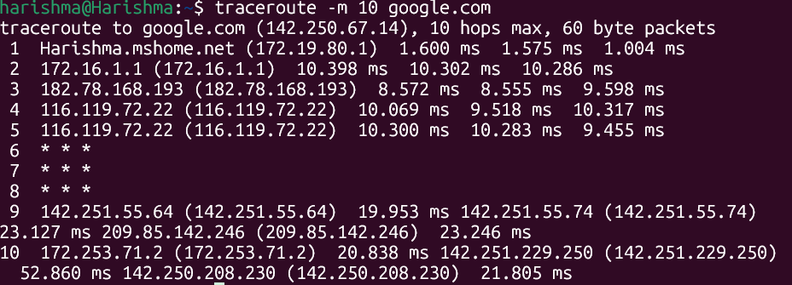

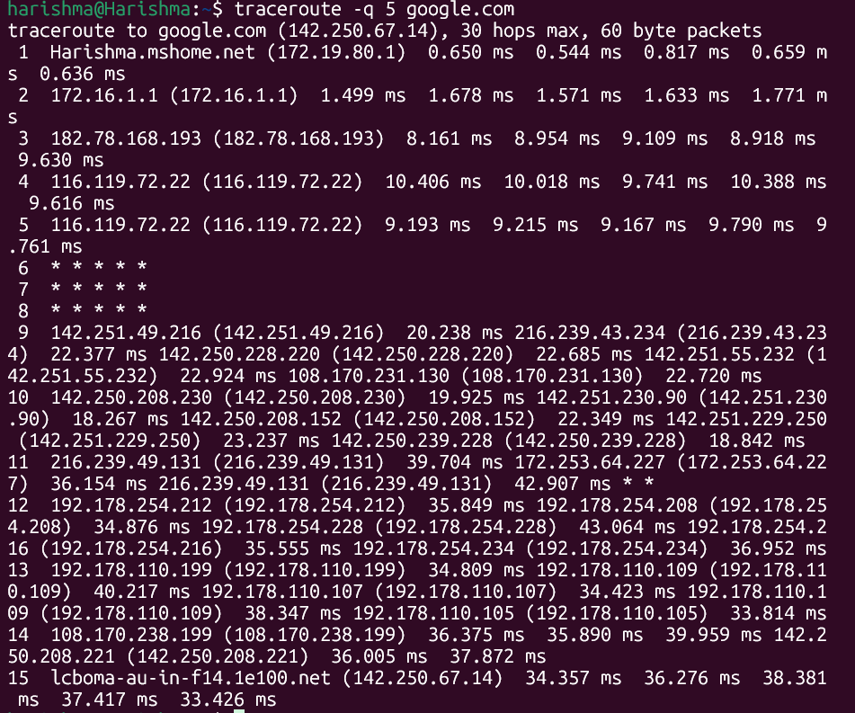
  - Change number of probes

  - Specify Port
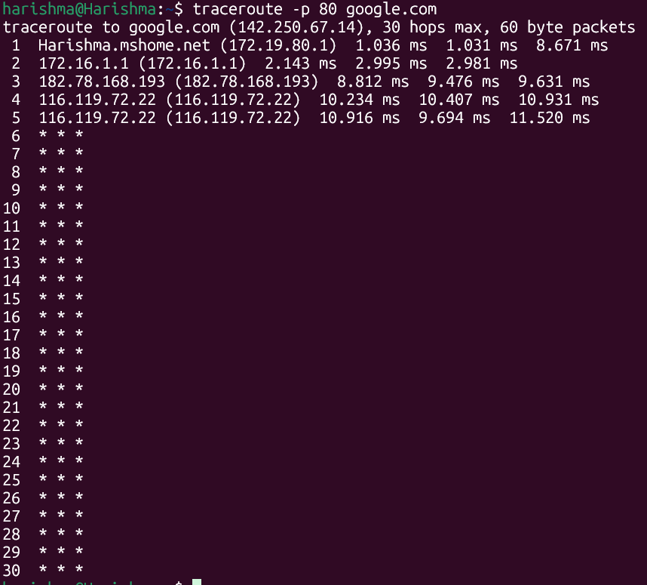
  - Resolve Hostnames
I 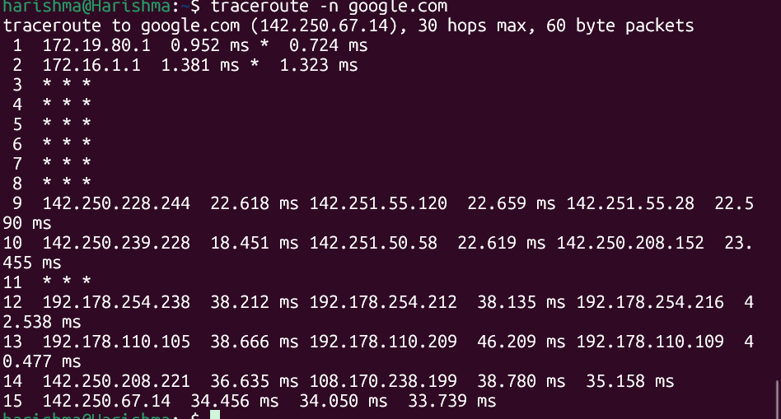
Use Cisco packet tracer for the below
- Set up trunk ports between switches and try ping between different VLANs
To configure VLANs on switches, establish a trunk link between them, and test communication between devices in different VLANs.
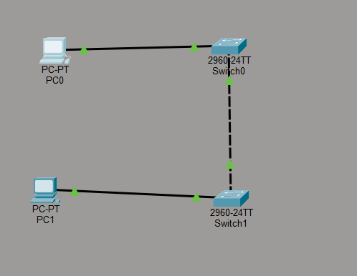

Step 1: Configure VLANs on Switch1
enable
configure terminal
vlan 10
name VLAN10
vlan 20
name VLAN20

Step 2: Assign PC1 to VLAN 10
interface fa0/1
switchport mode access
switchport access vlan 10

Step 3: Configure Trunk Port on Switch1
interface fa0/2
switchport mode trunk

Step 4: Configure Switch2 (Same VLANs)
enable
configure terminal
vlan 10
vlan 20

Step 5: Assign PC2 to VLAN 20
interface fa0/1
switchport mode access
switchport access vlan 20

Step 6: Configure Trunk on Switch2
interface fa0/2
switchport mode trunk

STEP 7: IP CONFIGURATION

PC1:
- IP: 192.168.10.2
- Subnet: 255.255.255.0

PC2:
- IP: 192.168.20.2
- Subnet: 255.255.255.0

STEP 8: TEST CONNECTIVITY
From PC1:
ping 192.168.20.2

EXPECTED RESULT
❌ Ping will FAIL
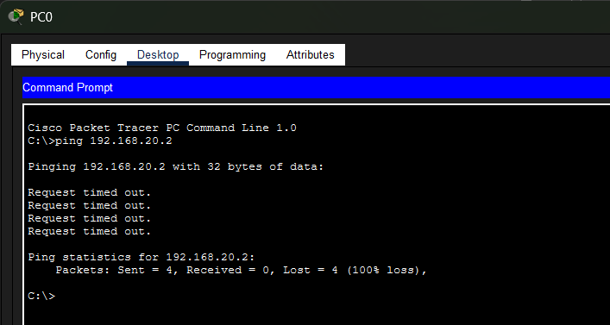

WHY PING FAILS (IMPORTANT CONCEPT)
- VLAN 10 and VLAN 20 are different broadcast domains
- Switches do NOT route traffic
- Only trunk carries VLANs — it does NOT enable communication
To communicate:
- You need a Router (Inter-VLAN Routing)
In this experiment, VLANs were configured on two switches and a trunk link was established between them using Cisco Packet Tracer. VLAN 10 and VLAN 20 were created on both switches, and access ports were assigned to connect end devices in their respective VLANs. The trunk ports were configured using the switchport mode trunk command, allowing multiple VLANs to be carried across the link between switches using 802.1Q tagging. IP addresses were assigned to the PCs in different VLANs, and a ping test was performed to check connectivity. The ping between devices in different VLANs failed, demonstrating that VLANs are isolated broadcast domains and switches do not perform routing. This experiment highlights the role of trunk ports in carrying VLAN traffic and reinforces the need for inter-VLAN routing to enable communication between different VLANs.
- Change the native VLAN on a trunk port. Test for VLAN mismatches and troubleshoot
To change the native VLAN on a trunk port, observe VLAN mismatch behavior, and troubleshoot connectivity issues.
• Native VLAN = VLAN that carries untagged traffic
• Default native VLAN = VLAN 1
• On trunk ports, both sides must match
- Open Cisco Packet Tracer and create a new workspace.
- From Network Devices, select two Cisco 2960 switches and place them on the workspace.
- From End Devices, select two PCs and place them near each switch.
- Connect PC1 to Switch1 using a copper straight-through cable (PC1 FastEthernet0 to Switch1 FastEthernet0/1).
- Connect PC2 to Switch2 using a copper straight-through cable (PC2 FastEthernet0 to Switch2 FastEthernet0/1).
- Connect Switch1 to Switch2 using a copper straight-through cable (FastEthernet0/2 to FastEthernet0/2).
- Configure IP address on PC1:
  - IP Address: 192.168.10.2
  - Subnet Mask: 255.255.255.0
- Configure IP address on PC2:
  - IP Address: 192.168.20.2
  - Subnet Mask: 255.255.255.0
- Open Switch1 CLI and enter the following commands:
- enable
configure terminal
vlan 10
vlan 20
vlan 99
interface fa0/1
switchport mode access
switchport access vlan 10
interface fa0/2
switchport mode trunk
switchport trunk native vlan 99
- Open Switch2 CLI and enter the following commands:
- enable
configure terminal
vlan 10
vlan 20
vlan 99
interface fa0/1
switchport mode access
switchport access vlan 20
interface fa0/2
switchport mode trunk
switchport trunk native vlan 99
- During initial configuration, observe the native VLAN mismatch warning when VLAN values differ between switches.
- Resolve the mismatch by configuring native VLAN 99 on both switches.
- Verify trunk configuration using the following command in privileged mode:
- show interfaces trunk
- Confirm that FastEthernet0/2 is operating in trunk mode and the native VLAN is set to 99 on both switches.
- Ensure proper connectivity and consistent VLAN configuration across both switches.

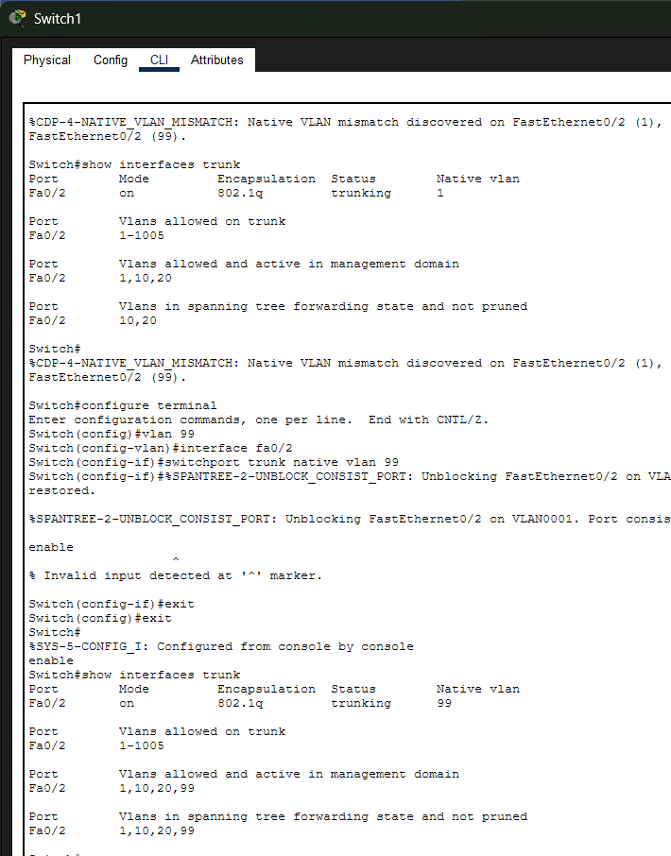

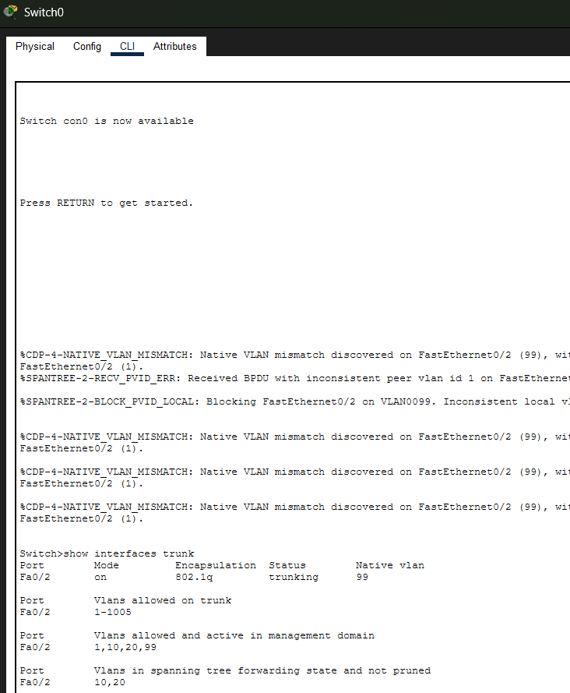
- Configure a management VLAN and assign an IP address for remote access. Test SSH or Telnet access to the switch
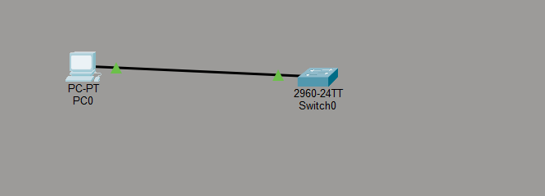

- Open Cisco Packet Tracer and create a new workspace.
- Place one Cisco 2960 switch and one PC on the workspace.
- Connect the PC to the switch using a copper straight-through cable (PC FastEthernet0 to Switch FastEthernet0/1).
- Configure IP address on the PC:
  - IP Address: 192.168.1.2
  - Subnet Mask: 255.255.255.0
- Access the switch CLI and enter privileged mode using enable, then enter global configuration mode using configure terminal.
- Create a management VLAN using the command vlan 99 and assign a name MANAGEMENT.
- Configure the VLAN interface and assign IP address:
  - interface vlan 99
  - ip address 192.168.1.1 255.255.255.0
  - no shutdown
- Assign the switch port to the management VLAN:
  - interface fa0/1
  - switchport mode access
  - switchport access vlan 99
- Configure the hostname using hostname S1 for SSH requirement.
- Configure domain name using ip domain-name lab.local.
- Generate RSA keys for SSH using crypto key generate rsa and select key size 1024 bits.
- Create a local user account using username admin password admin123.
- Configure VTY lines for remote access:
- line vty 0 4
- login local
- transport input ssh
- Verify configuration using show ip interface brief and show ip ssh commands.
- Test SSH from PC using command ssh -l admin 192.168.1.1 and confirm successful login to the switch.
